Learn about the exciting sport of Working Equitation and try your hand at the obstacles. Riders and horses of all levels and disciplines, Western and English, are welcome, gaited horses are welcome, no prior experience is necessary.
INTRO TO WORKING EQUITATION CLINIC
Saturday, April 30th at the Old Stone Farm
21172 287th St., Long Grove, Iowa
Riders: $80 includes an unmounted lecture and a small group lesson with obstacles. Helmets are required.
Payment submitted by April, 16th, 2022
Auditors: $20 in advance, $25 at the door
To register contact Sue Larkin (563) 343-7575
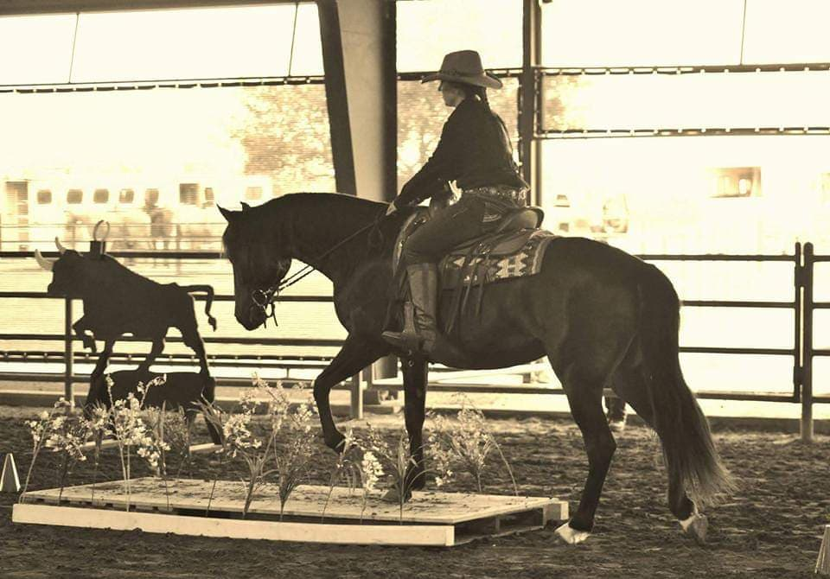
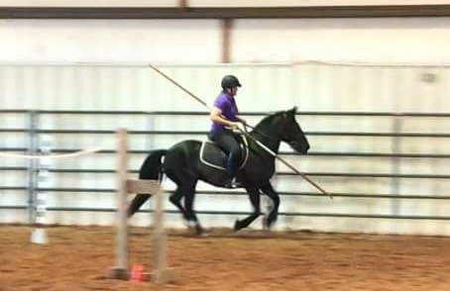
INSTRUCTOR:
Lidia Taylor
- Licensed “r” Judge and Technical Delegate with USA Working Equitation (USAWE.org)
- Certified instuctor by the American Riding Instructors’ Association
- Background in classical and Western Dressage
- Focus on correct biomechanics

